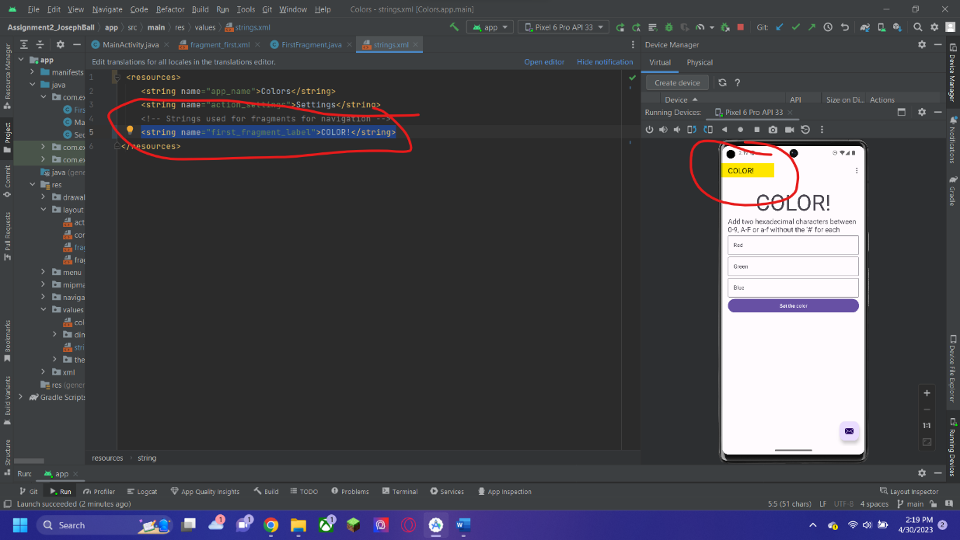

To start, I changed the title for the actual project in the strings.xml file in the values folder.

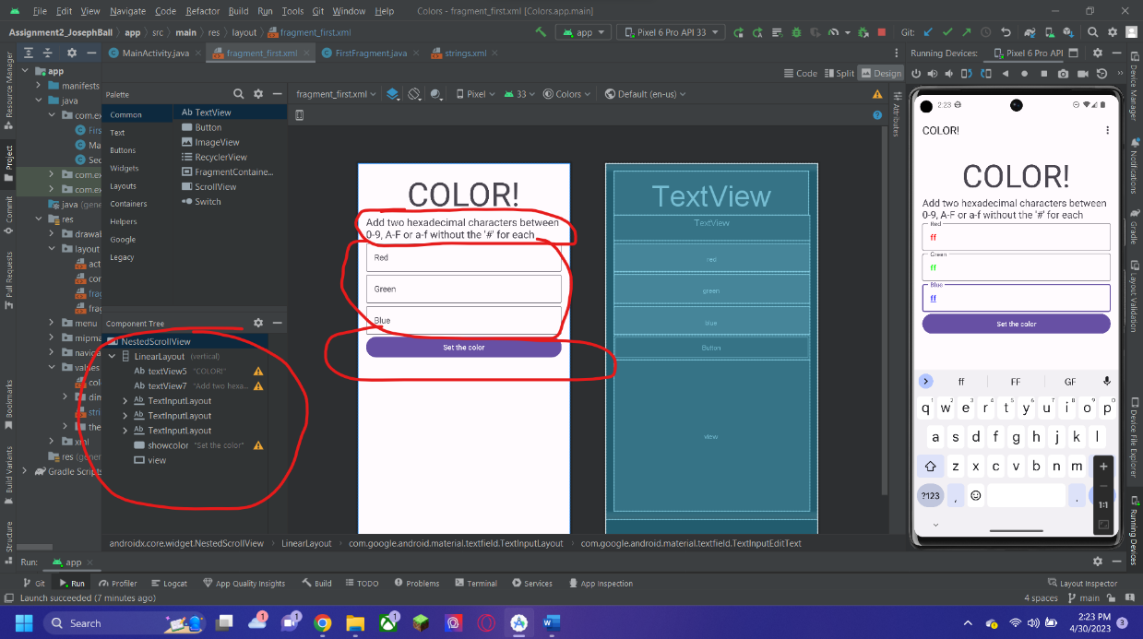

For the rest of the parts of the assignment, I created the text input fields, text view fields, and the button to set the color.

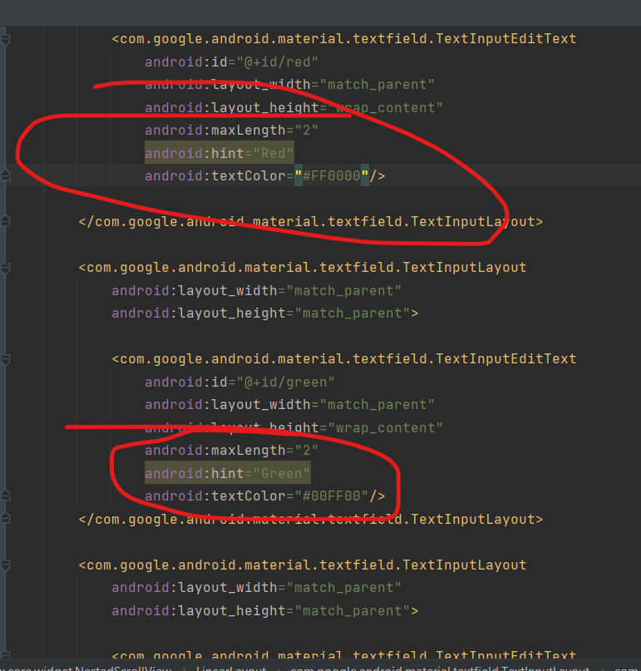

Then I set a max length of 2 so that the user cannot put in more than two characters, and as an added feature, I made it so that the text the user put in would appear red, blue, or green depending on what field they were typing in.

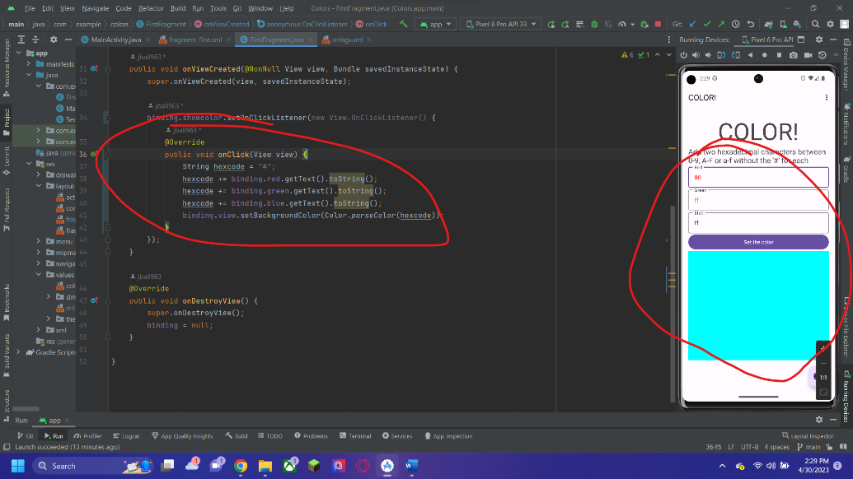

Then for the actual functionality of the code, in the fragment.java file, I made the code to get the values in the text fields by calling them from the ids that I set and adding them to a string to make a whole hex code. I then set the background color of the view that I made by taking the hexcode string that I built and used Color.parseColor() to set it as a valid color input.

Here is the link to my GitHub repository for the class: <https://github.com/jball963/Mobile-Apps>

This assignment is in: Week 2/assignment2_JosephBall